**Attention:**

Before you download and use the "MediCat Installer" file (double-click on the batch file (.bat)), you must turn off any "real-time scanning" in your antivirus software temporary, including Windows Defender. And leave it disabled until the USB stick has been created. Otherwise you will have applications get deleted from your USB stick during creation, and things won't work properly.

How to turn off Defender antivirus protection in Windows Security:

<https://support.microsoft.com/en-us/windows/turn-off-defender-antivirus-protection-in-windows-security-99e6004f-c54c-8509-773c-a4d776b77960>

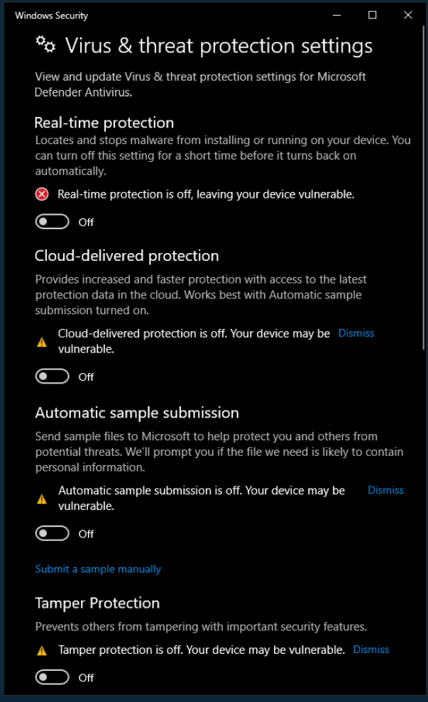

Requirements: An USB 3.0 stick with at least 32 GiB capacity (the download size is nearly 22 GiB).